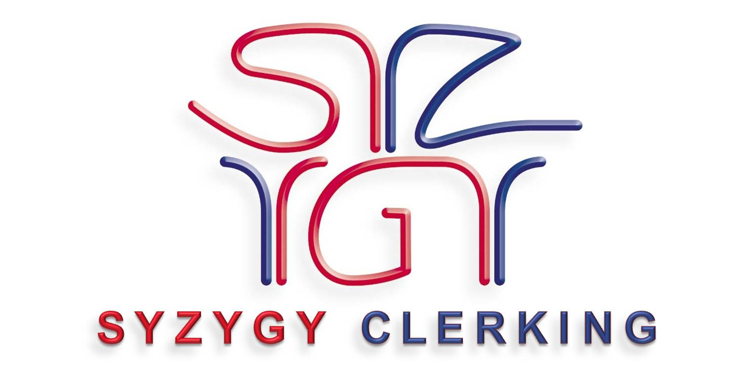
June 2018

for

Recruitment
Pack

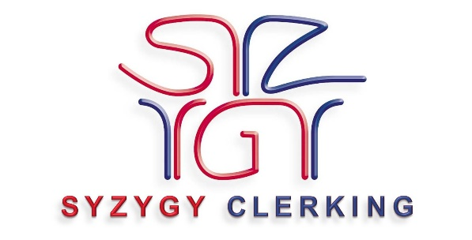

Dear Applicant
Thank you for the interest you have shown in working for Syzygy Clerking.
Please note that employment depends on your entitlement to work in the UK.
Please read the guidance notes, job description and person specification carefully before completing the application form and returning it by email.
We many verify information you have provided on the Application form (e.g. Qualifications, Skills, Knowledge, Experience and Salary) either prior to the interview or as part of the appointment process. This may involve contacting organisations or persons you have quoted on the form. You will have the opportunity to make representations should any checks produce discrepancies.
If you have been selected for interview we will contact you by email. If you haven’t heard from us within 4 weeks of the closing date, please accept that you have not been short listed and will not be asked for interview.
Yours sincerely
Liz Behnke
Company Director

GUIDANCE NOTES
When you apply for a job with Syzygy Leisure selection for interview is decided by the information you provide on the application form. With your application form you will have received:
- A Job Description - this gives you details about the job. It lists all the main tasks and duties which you will be required to carry out.
- A Person Specification - this tells you what qualifications, skills, knowledge and experience a person must have to be able to do the job. These are listed as essential and desirable criteria. In order to be invited for interview you must be able to show in your application form that you meet all the essential criteria and, ideally, all the desirable criteria. However, if you do not meet some or all of the desirable criteria we may still invite you for interview.

SOME POINTS TO BEAR IN MIND BEFORE YOU START
- Look carefully at the job description, person specification and application form. Ask yourself why you are interested in the job and what qualifications, skills, knowledge and experience you have which would help you to do the job.
- Make sure your application form gives information about how you can meet the requirements of the job description and person specification.
- Please use the application form provided, we do not accept CVs.

DATA PROTECTION
Syzygy Leisure maintains a register entry in respect of Staff Administration. Personal information provided by you on this form and any others in connection with your application is treated in confidence and complies with the requirements of the General Data Protection Regulations and Data Protection legislation in force at the time.

EQUAL OPPORTUNITIES
Equal Opportunities is important to us as a company. We do not collect data at recruitment stage as we take everyone on their merits. However, if you feel that we need to make any adjustment to assist you in making your application or during the recruitment, we would ask that you let us know in advance

APPLICATION FORM

SECTION A

POST APPLIED FOR: CLERK – ZERO HOURS CONTRACT.
Where did you see this advert?
Are you in possession of a full driving licence and have full use of a car? YES NO
In miles or minutes, how far are you willing to travel for an assignment?

SECTION B
Surname (block capitals): Preferred Title:
Forenames:
Home address:
Post Code:
Email address:
Telephone numbers:

SECTION C
Please give the name of two referees who can confirm your suitability for the post you are applying for. Referees must not be someone that you are related to, or in a relationship with.
Referee 1
Title: First Name: Surname:
Address:
Post Code:
Email address:
Telephone numbers:
How is this person know to you?

Referee 2
Title: First Name: Surname:
Address:
Post Code:
Email address:
Telephone numbers:
How is this person know to you?

DECLARATION
I declare that to the best of my knowledge the information contained in this application form is true and correct. I understand that if it is found that I have deliberately given false or misleading information I will, if appointed, be dismissed immediately without notice.

Signed: …………………………………………………………….

Name: ……………………………………………………………. Date: …………………………………………………

SECTION D

POST DETAILS
Please use this space to explain how your knowledge, skills and experience meet the person specification. The boxes will expand to fit the information you wish to supply
Criteria given in the Person Specification | Please explain how you meet the following criteria
- Skills, knowledge and aptitudes
- Qualifications and training
- Experience
- Personal attributes
- Special requirements

SECTION E
Provide summary details of where you work/worked in the last 10 years:
Employer | Job Title | From | To

EDUCATION
Please list in date order, starting with the most recent:
School/College | Qualifications obtained or to be taken | Grade | Date

PROFESSIONAL QUALIFICATIONS
Membership Body | Type of Membership | Title of Qualification | Date Obtained

OTHER TRAINING
Please give details of any other training relevant to the post you are applying for not covered in previous sections (eg short courses)
From | To | Details

Any other information you wish to add that explains how your knowledge, skills and experience match the job description:
Explanation given in the Job Description | Please explain how you meet this criteria

Syzygy Clerking
6 Church View,
Moulton,
Northants
NN3 7FZ
www.syzygyleisure.co.uk
admin@syzygyleisure.co.uk
01604 670222

